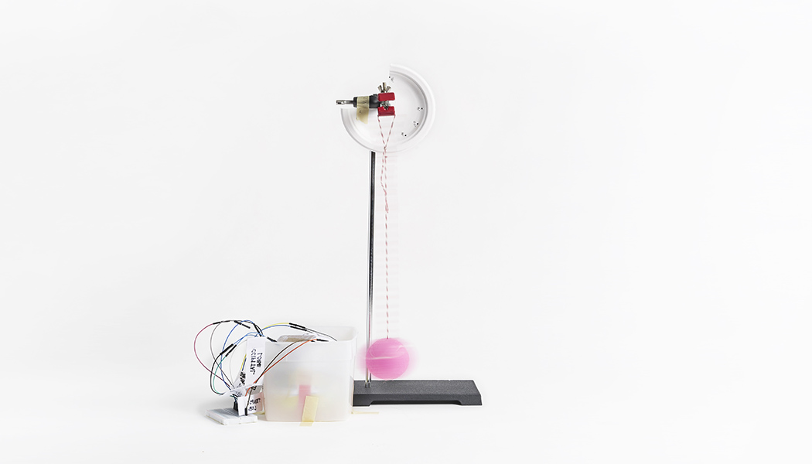­ ­­

Lesson plan and more resources are

available at: aka.ms/hackingstem

**BRAIN IMPACT SIMULATOR**

Building models to understand and mitigate brain injury

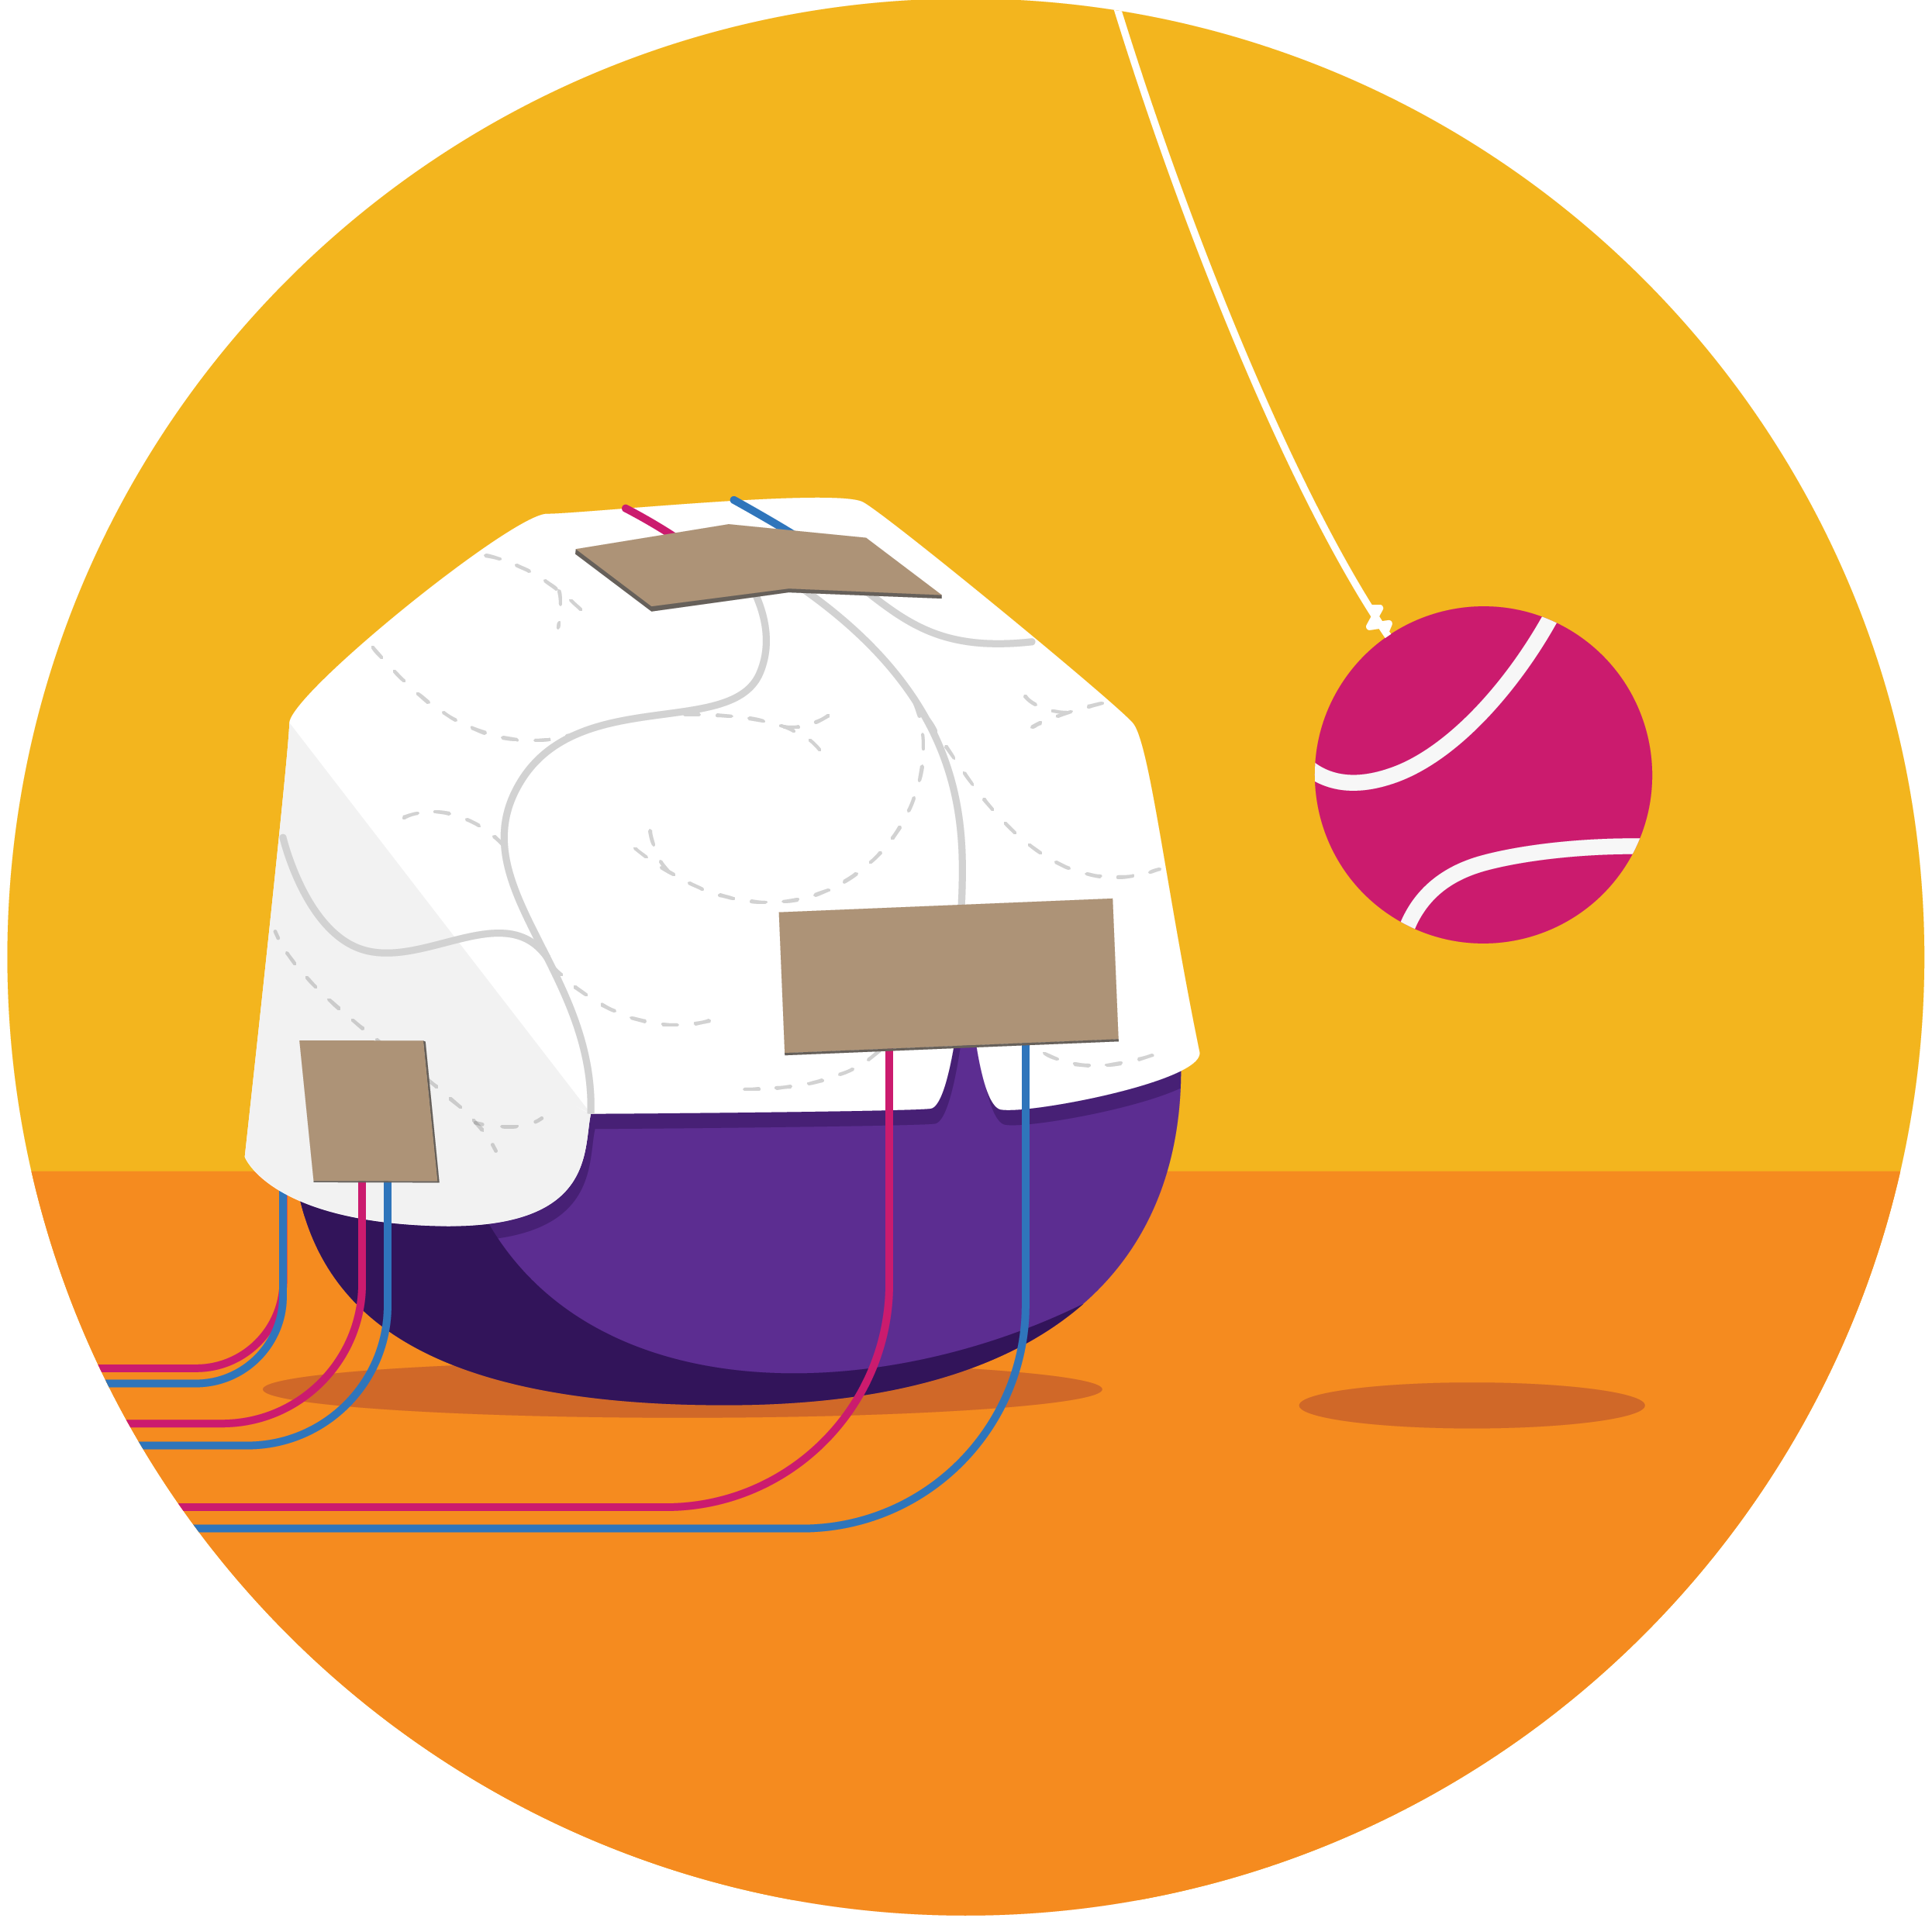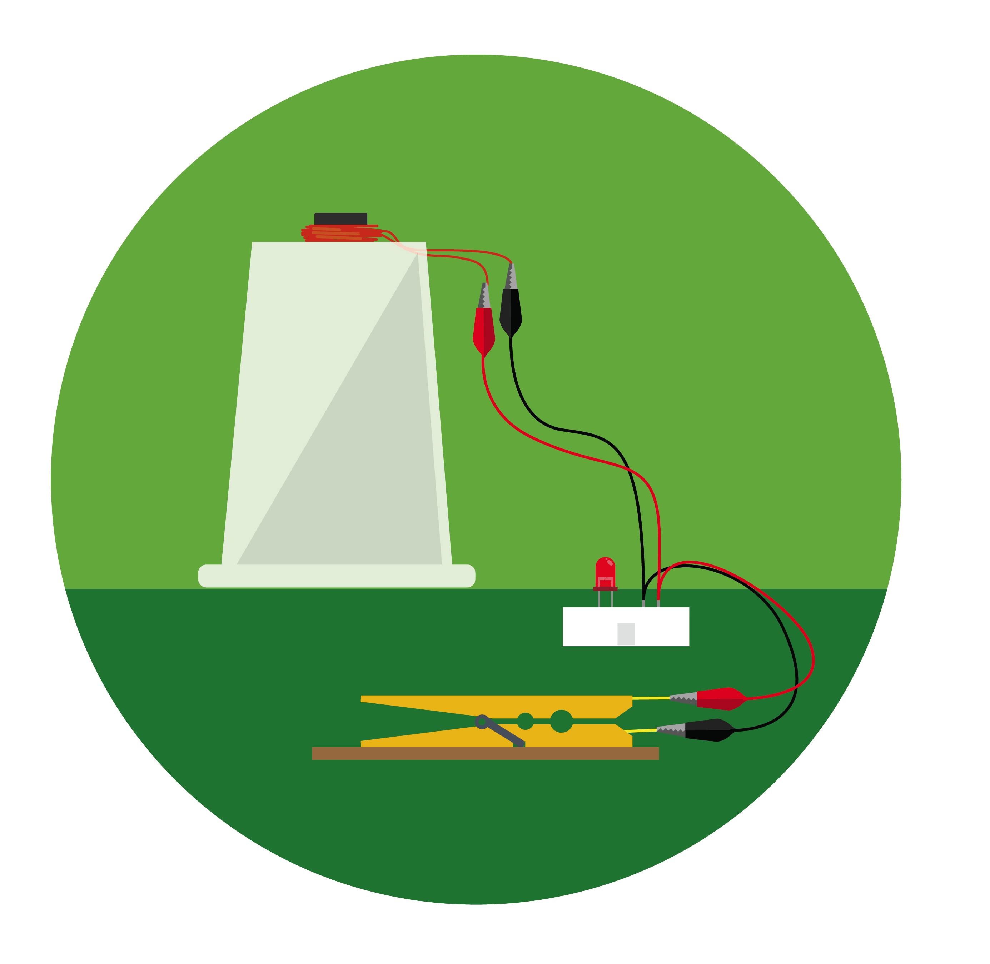

v

Activity overview

In this project, students investigate the impact of injury to one of the body’s most complex and powerful organs—the brain. Students construct a model of the human brain and equip it with impact sensors to measure the effect of a head collision. Using this data, students design protective head gear to mitigate injury.

View the full lesson plan mapped to NGSS and ISTE standards, materials, and activities to support this unit at [aka.ms/brain-impact-lesson/en](https://aka.ms/brain-impact-lesson/en)

Please note that lesson activities will require adult supervision.

../../../../../Desktop/4x/Asset%202@4x.png

Hack our projects

We love innovation and encourage you to hack our projects and make them your own. Submit your ideas at [aka.ms/hackingstem](https://aka.ms/hackingstem)

Contents

**02** Activity overview

**03** Things you’ll need

**04** Build brain model

**05** Create a brain hat

**06** Build pressure sensors

**10** Create pendulum

**12** Connect Arduino

**14** Upload Arduino code

**15** Connect micro:bit

**17** Upload micro:bit code

**18** Data Streamer set-up

**20** Workbook basics

**24** Brain hat template

Build and learn

Students build a brain impact simulator to visualize the effects of head collisions. Sensors on the simulator measure the amount of pressure the brain experiences when hit by a pendulum.

Connect your tools

Digitize your device using either the Arduino Uno or micro:bit. Students learn essential prototyping and electrical engineering skills by connecting the brain impact simulator to Excel to visualize the impact on the brain.

Visualize the data

Using a customized Excel workbook, students visualize the magnitude of the pendulum impact on the brain and analyze how each region is affected. Students can run and save multiple trials to compare impact data. This data informs students’ design of protective head gear.

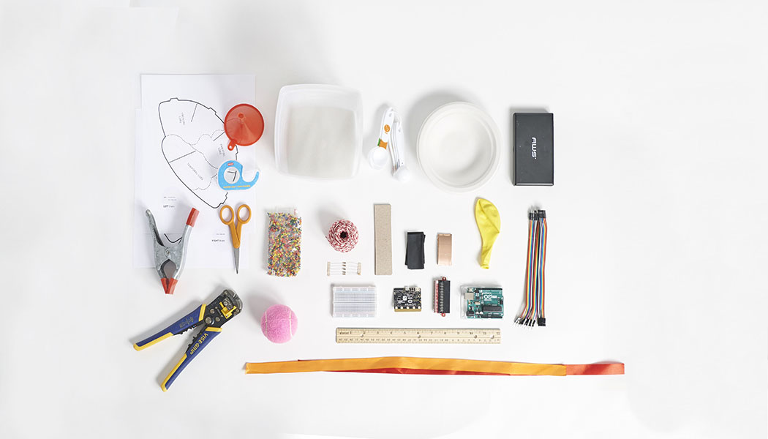

|  |
| --- |
| Things you’ll need |

|  |  |
| --- | --- |
| **Materials**  1 printed brain hat template, pg. 24  5 strips of cardstock 3 cm x 12 cm  10 strips copper tape 2.5 cm x 5.5 cm  10 strips of Velostat 3 cm x 6 cm  17 male-to-male jumper wire  10 female-to-female jumper wire  5 100-ohm resistors  1 tennis ball  50+ metal washers  string  paper plate  1 30.5 cm (12 in) balloon  Optional: ~10-grams absorbent polymer water beads  1 square container for holding balloon  2 lengths of ribbon (45 cm in length)  **Reusables**  1 microcontroller (Arduino or micro:bit)  1 edge connector if you are using micro:bit  1 USB cable A-to-B for Arduino  1 USB cable micro for micro:bit  1 breadboard | **Toolkit**  wire stripper  clear tape  ruler  scissors  gram scale or measuring spoons  funnel  hot glue gun  ***Safety guidelines***  ***Hot Melt Tool***   * *Place it on a level surface to avoid tipping over.* * *Place the electrical cable out of the way to avoid a tripping hazard.* * *Do not touch the tip of the tool or the hot glue coming out of it.*   ***Eye Protection***   * *Please wear appropriate eye protection while doing any engineering design or field projects.*   ***Cutting Tools***   * *Keep the sharp edge away from your body.* * *Always cover the blade with a plastic cap when not in use.* * *When cutting small pieces, do not place fingers very closed to the blades.*   ***Wire Strippers***   * *Always keep your fingers and hands out of the cutting area.* |

**Making for a group or need help finding materials?**

View the shopping list to calculate quantities at: [aka.ms/brain-impact-materials/en](https://aka.ms/brain-impact-materials/en)

Build your brain model

Note: If you use water beads, it takes several hours for absorption to occur.

|  |  |  |
| --- | --- | --- |
|  |  |  |
| **1** | Gather your materials. Water beads reduce potential for mess and produce a model that simulates a brain more convincingly. It is possible to omit water beads and simply use a balloon full of water. |  | **2** | Measure your water beads before filling the balloon. For a 15 cm diameter balloon, 10 grams or 2 teaspoons is ideal. Depending on the size of your container and balloon, you may need to adjust these measurements. |
|  |  |  |
|  |  |  |
| **3** | Use a funnel to add water beads to dry balloon. |  | **4** | Support the balloon bottom and around nozzle and fill with water to size that fits your container. When the balloon is full it should be about 1 cm from each edge of the container. |
|  |  |  |
|  |  |  | |
| **5** | Release any air from the balloon and tie the end. |  | **6** | After several hours an ideal balloon will have a small amount of unabsorbed water and will be pliable. | |

Create a brain hat for your brain model

|  |  |  |
| --- | --- | --- |
|  |  |  |
| **1** | Print out your brain hat on page 24 at 70% scale to fit your balloon. |  | **2** | Cut out both brain hat pieces by cutting on the solid black lines. |
|  |  |  |
|  |  |  |
| **3** | Find the cut line in each lobe, slide it over the shaded area and then tape it. This will create a hemisphere shape for each side of the brain hat. |  | **4** | Using the tabs on the top of the brain hat, fasten the two halves together with tape. |
|  |  |  |
|  |  |  | |
| **5** | Fit the smaller balloon brain hat to the balloon. Be sure it is a snug fit. Remove the brain hat from the balloon and reinforce with tape wherever needed. |  |  | |

Build pressure sensors

|  |  |  |
| --- | --- | --- |
|  |  |  |
| **1** | Gather your materials. To build your first pressure sensor you’ll need 1 piece of 3cm x 12cm cardstock, 2 pieces of 2.5cm x 5.5cm copper tape, 2 pieces of 3cm x 6cm Velostat, and 2 female-to-female jumper wires. |  | **2** | Fold the cardstock in half across its length. |
|  |  |  |
|  |  |  |
| **3** | Peel the backing from your copper tape trying to not to crease or bend it. |  | **4** | On the inside of the folded cardstock, place the copper tape into the center of one of the folded ends. |
|  |  |  |
|  |  |  | |
| **5** | Do the same for the other end of your cardstock piece. |  | **6** | Cut the connectors off one end of 2 of the  female-to-female jumper wires. | |
|  |  |  | |
| **7** | Strip 2.5 cm of insulation off both wires. |  | **8** | Using clear tape, attach one wire to the inside edge of one piece of copper tape, and one to the outside edge of the other piece of copper tape. Be sure to leave the center of the copper tape exposed. | |
|  |  |  | |
|  |  |  | |
| **9** | Place 2 pieces of Velostat onto one side of the copper tape. |  | **10** | Fold over the paper to complete the sensor sandwich. | |
|  |  |  | |
|  |  |  | |
| **11** | Tape all edges with clear tape and secure the wires to the paper of the sensor. |  | **12** | Repeat steps 2-9 four more times to make a total of 5 sensors. | |
|  |  |  | |
|  |  |  | |
| **13** | Gently bend each one of the sensors to match to the shape of the brain hat. |  | **14** | Tape a sensor to each of the major lobes (frontal, right temporal, left temporal, occipital, and parietal) of the brain. | |
|  |  |  | |
|  |  |  | |
| **15** | When all the sensors are attached, the brain hat should look like this. |  | **16** | Attach a male-to-male jumper wire to each of the sensor wires. | |
|  |  |  | |
|  |  |  | |
| **17** | For ease of breadboarding later, it is recommended that you label each lobe you have put a sensor on and then attach it to the end of breadboarding wires. |  |
|  |  |

Attach ribbons to secure brain hat to model

|  |  |  |
| --- | --- | --- |
|  |  |  |
| **1** | Place ribbon end onto left frontal lobe and tape. |  | **2** | Using the second ribbon, repeat step 1 on right frontal lobe. |
|  |  |  |
|  |  |  |
| **3** | Turn the brain hat upside down and place balloon in brain hat. |  | **4** | Cross one ribbon diagonally to occipital lobe so the ribbon is snug to the balloon and tape as you did in step 1. |
|  |  |  |
|  |  |  | |
| **5** | With remaining ribbon, repeat step 4 to firmly secure the paper brain to your balloon. |  | **6** | Flip your balloon over and place it into your container. Set aside. | |

Create your pendulum

|  |  |  |
| --- | --- | --- |
|  |  |  |
| **1** | Take your paper plate and make a mark approximately in the center. |  | **2** | Using a protractor, mark 0, 30, 60, 90, 180, and 270 degrees on your plate. |
|  |  |  |
|  |  |  |
| **3** | Make a cut at the lines for 180 and 270 degrees to create a swing gauge. |  | **4** | Take your tennis ball and carefully cut a slit in it about 2cm wider than the washers. Warning: to avoid injury, it is recommended to place tennis ball in a vice when cutting. |
|  |  |  |
|  |  |  | |
| **5** | Obtain a structure that you can attach your string and tennis ball to. This could be as simple as a table or a few pieces of wood and a clamp. In this example, we are using a ring stand. |  | **6** | Cut a piece of string slightly longer than your pendulum stand. The length of your string will depend on how high  your pendulum stand is. | |
|  |  |  | |
|  |  |  | |
| **7** | Tie a few washers onto one end of your string. This will act as an anchor for your tennis ball. |  | **8** | Squeeze the tennis ball to open the slit and drop the anchor into the tennis ball. | |
|  |  |  | |
|  |  |  | |
| **9** | Fill your tennis ball about 2/3 full of washers and then seal the tennis ball by hot gluing the slit closed. |  | **10** | Tape your container down to the table where you’ll be testing. | |
|  |  |  | |
|  |  |  | |
| **11** | Tie the string from your tennis ball pendulum to the end of the arm. |  | **12** | Attach your swing gauge next to where you tied your pendulum. You’ll use this to repeat your tests. | |
|  |  |  | |

**Congratulations!** You’re now ready to connect your Impact Simulator to your microcontroller to begin getting data from your device. If you are using the Arduino Uno, turn to page 12. If you are using the micro:bit, skip to page 15.

|  |  |  |  |  |  |  |  |  |  |  |  |  |  |  |  |  |  |  |  |  |  |  |  |  |  |  |  |  |  |  |  |  |  |  |  |  |  |  |  |  |  |  |  |  |  |  |  |  |  |  |  |  |  |  |  |  |  |  |  |  |  |  |  |  |  |  |  |  |  |  |  |  |  |  |  |  |  |  |  |  |  |  |  |  |  |  |  |  |  |  |  |  |  |
| --- | --- | --- | --- | --- | --- | --- | --- | --- | --- | --- | --- | --- | --- | --- | --- | --- | --- | --- | --- | --- | --- | --- | --- | --- | --- | --- | --- | --- | --- | --- | --- | --- | --- | --- | --- | --- | --- | --- | --- | --- | --- | --- | --- | --- | --- | --- | --- | --- | --- | --- | --- | --- | --- | --- | --- | --- | --- | --- | --- | --- | --- | --- | --- | --- | --- | --- | --- | --- | --- | --- | --- | --- | --- | --- | --- | --- | --- | --- | --- | --- | --- | --- | --- | --- | --- | --- | --- | --- | --- | --- | --- | --- | --- |
| Connect your Arduino    **Frontal**  **Lobe**   |  |  |  | | --- | --- | --- | | **1** | Connect a male to male jumper wire from 5V on the Arduino to the + column on your breadboard. Connect another male to male jumper wire from GND on the Arduino to the – column on your breadboard. |  | **2** | Connect a male to male jumper wire into A0 on the Arduino and an empty row on the breadboard. | | **3** | In the same row, connect one 100-ohm resistor. One pin of the resistor should be in that row and the other should be in the – column. This should be the same column you plugged into GND. |  | **4** | Finally, take the wires from the Frontal Lobe sensor, and connect one into the same row as the resistor and one into the + column. This should be the same column you plugged into 5V. |   Circuit images made with Fritzing and are licensed for use under CC by SA 3.0. See <http://creativecommons.org/licenses/by-sa/3.0/> for the full description.  Connect your Arduino (cont.)    **L Temporal**  **Lobe**  **R Temporal**  **Lobe**  **Occipital**  **Lobe**  **Parietal**  **Lobe**  **Frontal**  **Lobe**   |  |  |  | | --- | --- | --- | | **5** | Repeat steps 2-4 four more times to complete the wiring. Connect each sensor to the next pin in the Arduino, A1, A2, A3, and A4. |  |  | |  |  |  |     **CONCEPT IN ACTION**  **How does a pressure sensor work?**  Velostat is a plastic that is blended with carbon to make it semi-conductive. When the plastic has pressure applied to it, the carbon molecules that are dispersed within the plastic get closer together allowing electrical current to flow more easily through the material. The amount of current that is allowed through the plastic is directly proportional to the pressure applied allowing the microcontroller to read a larger voltage across the plastic as more pressure is applied.  Upload Arduino code   |  |  |  |  | | --- | --- | --- | --- | |  |  |  |  | | **1** | Install the Arduino IDE from the Technical Requirement link on the lesson page at [aka.ms/hackingSTEM](https://aka.ms/hackingstem) or through the Microsoft Store. Follow prompts to complete the installation. |  |  | **2** | Go to [aka.ms/brain-impact-code](https://aka.ms/brain-impact-code) and download the flash code. | |  |  |  |  | |  |  |  |  | | **3** | Open your downloaded file to launch the Arduino app. |  |  | **4** | In the Arduino app, select: Tools > Port > COM 3 (Arduino/Genuino Uno). Your port may be different than COM3. | |  |  |  |  | |  |  |  |  | | **5** | Then select Tools > Board: Arduino/Genuino Uno. |  |  | **6** | Click on the circular right arrow button to upload. |   Connect your micro:bit    **Frontal**  **Lobe**   |  |  |  | | --- | --- | --- | | **1** | Plug your micro:bit into the edge connector and then plug the edge connector pins into the breadboard. |  | **2** | Connect a jumper wire from 3.3V on the micro:bit to the + column on your breadboard. Connect another jumper wire from GND on the micro:bit to the **–** column on your breadboard. | | **3** | Connect a jumper wire into 0 on the micro:bit and an empty row on the breadboard. |  | **4** | In the same row connect one 100-ohm resistor. One pin of the resistor should be in that row and the other should be in the – column. This should be the same column you plugged into GND. |  |  |  |  | | --- | --- | --- | | **5** | Finally, take the wires from the Frontal Lobe sensor, and connect one into the same row as the resistor and one into the + column. This should be the same column you plugged into 3.3V. |  |  |   Connect your micro:bit (cont.)    **Frontal**  **Lobe**  **Parietal**  **Lobe**  **L Temporal**  **Lobe**  **R Temporal**  **Lobe**  **Occipital**  **Lobe**   |  |  |  | | --- | --- | --- | | **6** | Repeat steps 2-4 four more times to complete the wiring. Connect each sensor to the next pin, 1, 2, 3, and 4. |  |  | |  |  |  |     **CONCEPT IN ACTION**  **How does a pressure sensor work?**  Velostat is a plastic that is blended with carbon to make it semi-conductive. When the plastic has pressure applied to it, the carbon molecules that are dispersed within the plastic get closer together allowing electrical current to flow more easily through the material. The amount of current that is allowed through the plastic is directly proportional to the pressure applied allowing the microcontroller to read a larger voltage across the plastic as more pressure is applied.  Upload micro:bit code   |  |  |  |  | | --- | --- | --- | --- | |  |  |  |  | | **1** | Go to [aka.ms/brain-impact-code](https://aka.ms/brain-impact-code) to download the .hex code file. |  |  | **2** | Plug your micro:bit to your computer using a USB cable. [Install the mbed driver](https://os.mbed.com/docs/v5.9/tutorials/windows-serial-driver.html). If you’ve done this before, you won’t have to do it again. | |  |  |  |  | |  |  |  |  | | **3** | In File Explorer, navigate to the micro:bit. It will appear like an external storage device (e.g. thumb drive, hard drive, etc.). |  |  | **4** | Open a second File Explorer window and navigate to the downloads folder. Make sure you can see both windows. | |  |  |  |  | |  |  |  |  | | **5** | Select the .hex file in downloads and drag it to the micro:bit window. |  |  | **6** | Once the LED light stops blinking, the code has been uploaded onto the micro:bit. | |  |  |

Open Excel and enable Data Streamer

Data Streamer with Excel O365. The O365 subscription includes Excel and the Data Streamer add-in for free.

|  |  |  |
| --- | --- | --- |
|  |  |  |
| **1** | Open Excel 0365. |  | **2** | Click on **File** and choose **Options** located at the bottom of the pane. |
|  |  |  |
| **3** | Choose **Add-ins** in the dialog that opens. |  | **4** | From the **Manage** menu at the bottom of the dialog that opens, choose **COM Add-Ins** and click **Go** |
|  |  |  |
| **5** | Check the box for **Microsoft Data Streamer**  in the dialog that opens and click **OK.** |  | **6** | You should see a new Data Streamer tab in Excel’s menu ribbon. |

**Data Streamer with Excel O365 desktop version**

For a limited time, Data Streamer can be used with the desktop version of Excel 2016. Download Data Streamer from the Microsoft Store. After installation, Data Streamer will be automatically enabled in Excel.

Get ready to visualize data

**To run the Data Streamer Add-in, make sure you meet these technical requirements:**

* PC running Windows 10 and Excel O365 Desktop.
* Enable the Data Streamer add-in. See instructions on previous page.
* Customized Excel Workbook available at: [aka.ms/brain-impact-workbook](https://aka.ms/brain-impact-workbook)

Congratulations! You are now ready to visualize real-time data from the Electroconductivity sensor sensor. To see live data, follow these steps:

|  |  |  |
| --- | --- | --- |
| **1** | Plug the Arduino or micro:bit microcontroller into your computer’s USB port |  | **2** | Click the Data Streamer tab on the Excel ribbon |
| **3** | Click Connect a Device to connect Excel to the microcontroller |  | **4** | Start Data to begin streaming data into Excel |
|  |  |  |
|  |  |  |

To connect your device, plug it into your computer via USB and then click “Connect a Device.”

Once your device is connected, select “Start Data” to begin streaming data into Excel. If you do not click “Start Data” when your device is plugged in, you will not see any live data.

If you have recorded and saved a data file (.csv), you can import it with this button

Excel workbook basics

Concussion data by sport

This worksheet’s function is to give background information on concussions and their causes, Please note that the bottom of the worksheet has a link to the data source where students can dive deeper into the data.

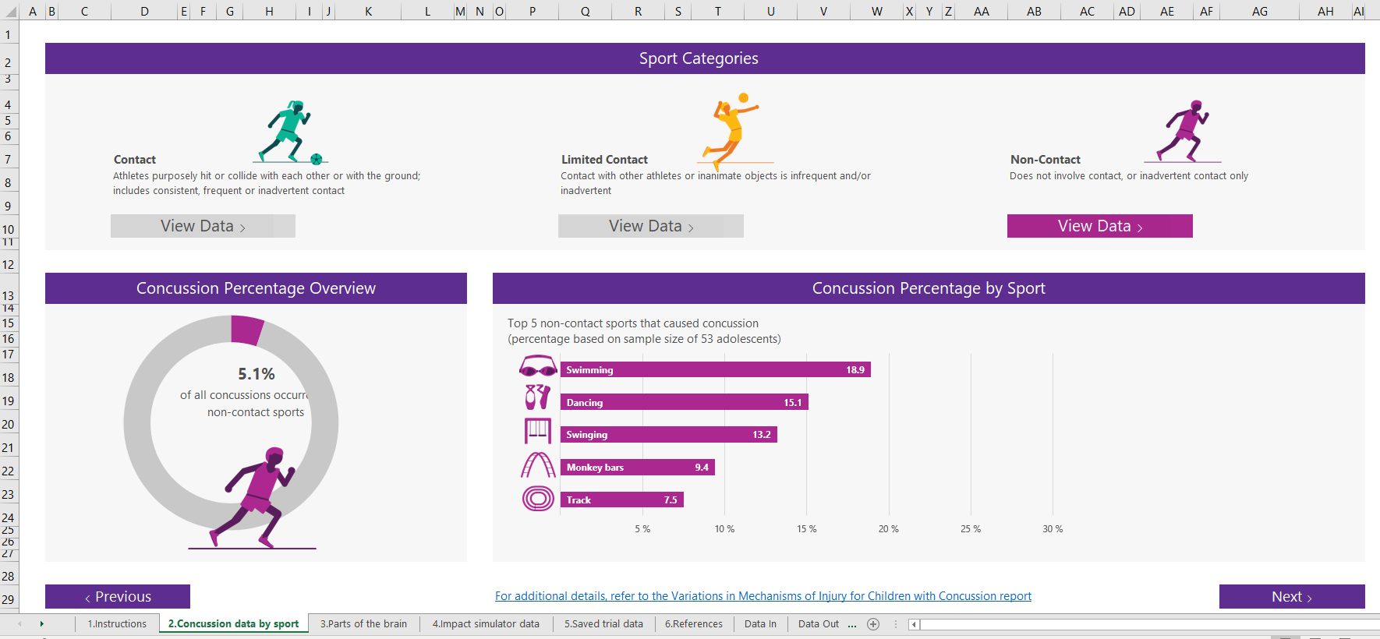

When you are finished with this worksheet, click the “Next ” button to proceed.

Excel workbook basics (cont.)

Brain regions

In this worksheet, students learn the different lobes of the brain and their corresponding functions. Students may explore the 3D brain by spinning it on the left side of the worksheet or they may click “VIEW” on each lobe to snap the brain visual into the correct position for viewing.

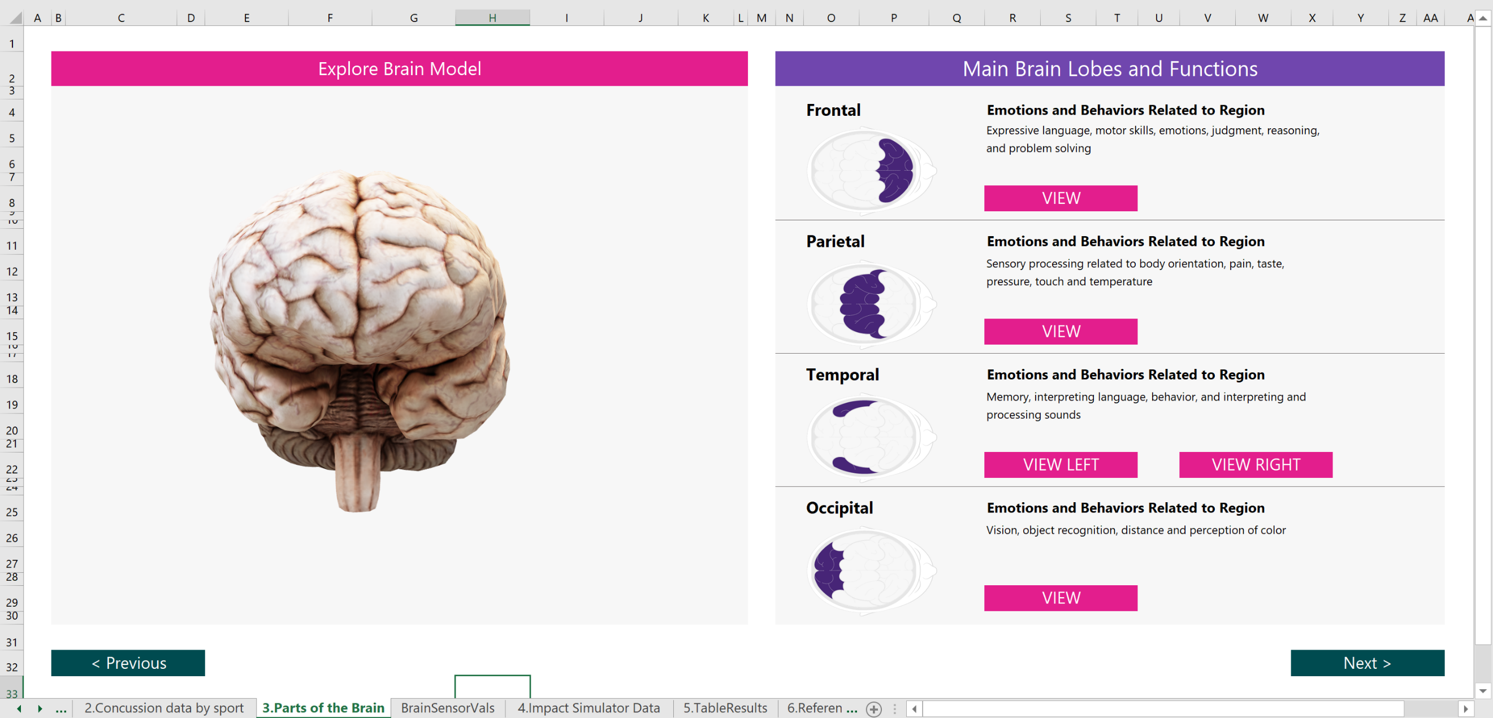

**Important:** if you accidentally delete or resize the 3D brain, press the Undo button at the top of the Excel banner BEFORE you click on any other buttons in the workbook. Otherwise, you will have to reopen the workbook to get the brain back to its original form.

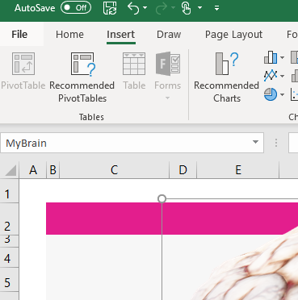

When you are finished with this worksheet, click the “Next ” button to proceed.

Excel workbook basics (cont.)

Impact simulator data

In this sheet, you can stream live impact data into the Excel spreadsheet and run trials. You will need to have the [Data Streamer add-in](https://aka.ms/data-streamer) enabled as well as have your brain impact simulator plugged in to stream data. On the left side of the worksheet, line graphs show changing pressure being applied to each sensor while the right side of the page contains visualizations of brain impacts organized by trial.

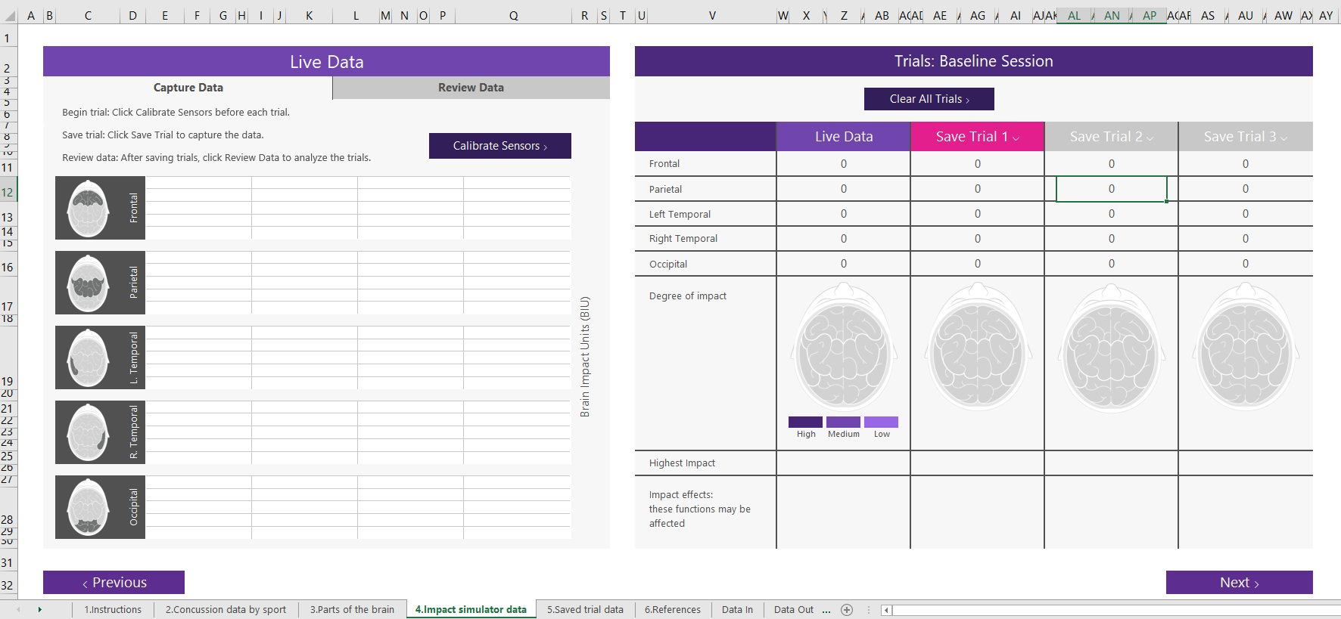

Capture Data

With the Capture Data tab (at the top left of the page) active, click Start Data in Data Streamer add-in to begin streaming data. If your design is hooked up correctly, lines will begin flowing from right to left from each of the five sensors. Make sure each sensor is hooked up and reading correctly by gently pressing on each, one by one. If done correctly, that line should rise substantially. Other sensors may register the pressure as well, but if the sensors were built correctly, the sensor that shows the greatest change in pressure should be the physically pressed sensor. Before running each trial, click “Calibrate Sensors” to zero out the sensors.

Review Data

Once the Review Data tab is selected, you will see a few new controls appear above the line graph. Use the arrows to scrub through the timeline to view the captured data moment by moment. Notice how the impact spreads to other areas even though the brain was only hit in one area.

Trial Summary

On the right side of the worksheet is the trial summary section where you may save up to three trials at a time. You can compare the summary of your trials and view the highest impact area for each trial. The “Save Session” button will store the data series to the next tab in the workbook where you can compare multiple data sessions later.

Page Intentionally left blank

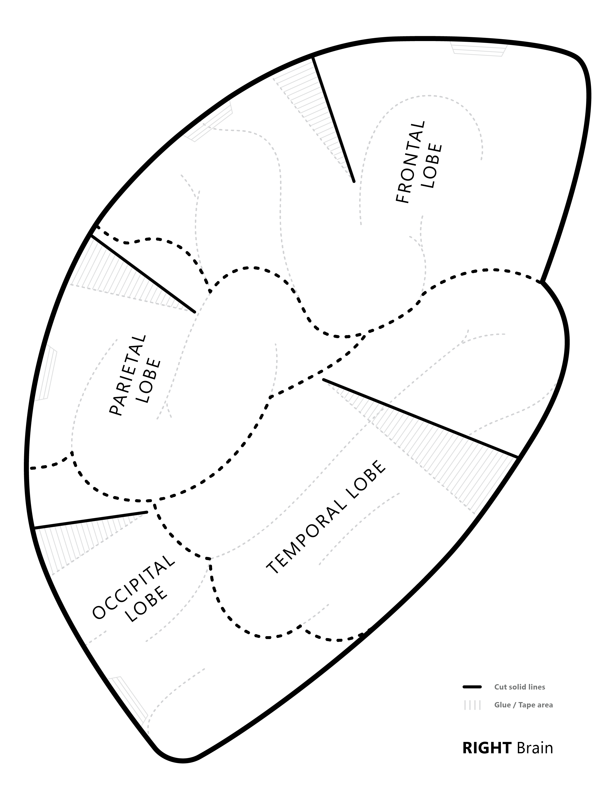Brain Hat Template

**Print at 80% for the balloon**

Page Intentionally left blank

